Nadia Rouatbi - Abstract Acrylic Art

Exploring the boundaries of color and form

https://drive.google.com/drive/folders/1XH8NGULt91khR-jc_IaNkZQ1UQb0HkpT?usp=sharing
Biography
Born on August 2, 1980, in Paris, currently living in Riyadh, Nadia Rouatbi is a Tunisian artist whose creative journey bridges continents, disciplines, and identities. Though she pursued mechanical engineering at Université Claude Bernard in Lyon, her lifelong passion for art never left her. Years later, after building her family, she turned fully toward her
artistic calling, immersing herself in rigorous training with both internationally acclaimed and regionally celebrated artists.

Her work is a quiet rebellion: her visual language is deeply introspective, inviting viewers to reflect on the unseen boundaries: cultural, emotional, and imagined, that shape how we perceive ourselves and others.

Alongside her studio work, she remains committed to expanding her technical and conceptual skills through ongoing workshops and continuous learning and practice.

Gallery
Painting | Brief Description
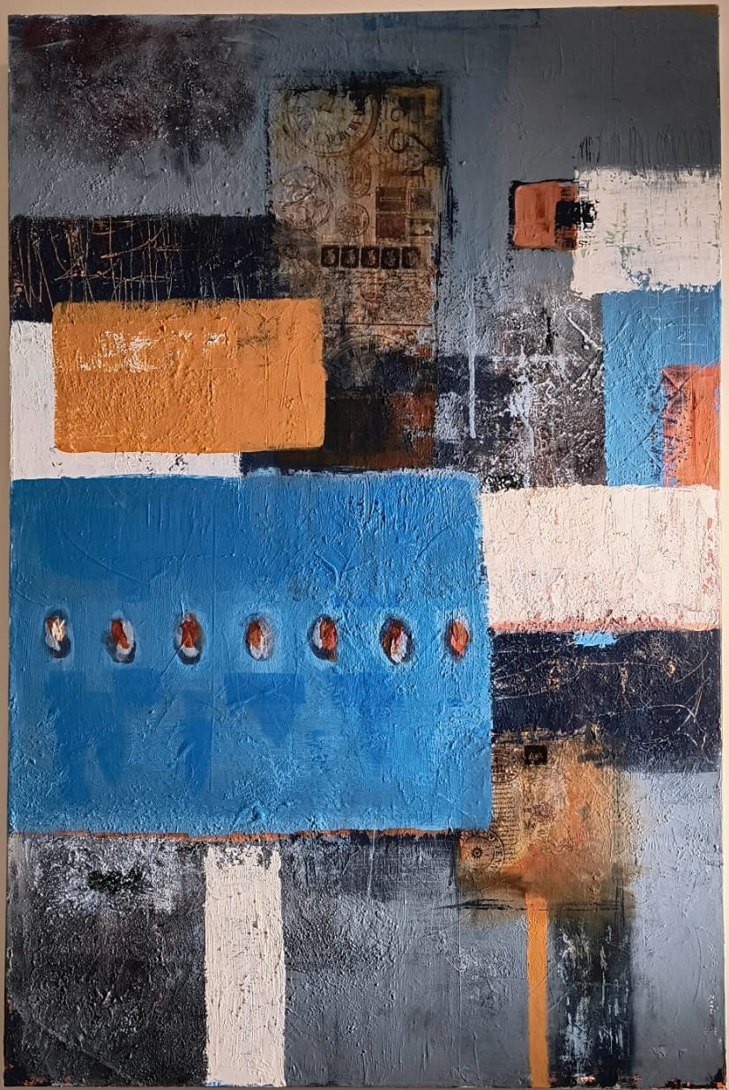 | "Boundaries", Acrylic Ultra Textured  This dynamic mixed-media abstract piece balances bold geometric blocks in bright cyan, white, and rust orange against a heavily textured, collage-like background of cool greys and deep indigo. The composition features a row of seven small, embedded circular elements set into the dominant blue rectangle, adding a rhythmic focal point.  120x80cm, Acrylic on canvas
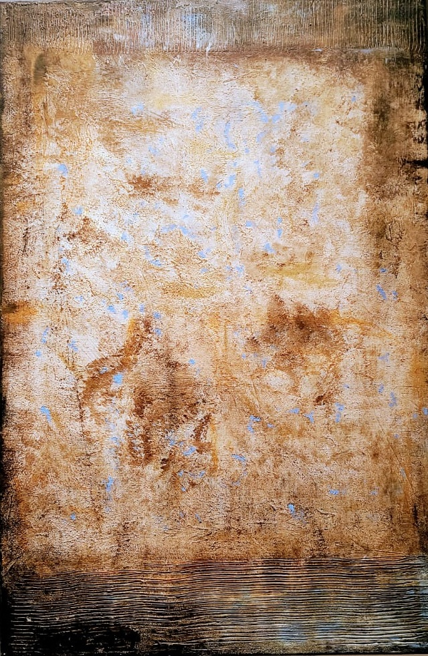 | "Time-Worn", Acrylic Ultra Textured  This abstract work features a deeply textured, earthy palette of ochre and brown, reminiscent of aged material. Heavy impasto dominates the surface, contrasted by subtle flecks of pale blue. The piece is framed by distinct, deeply carved horizontal lines at the top and bottom edges, emphasizing its tactile quality.  100x75cm, Acrylic on canvas
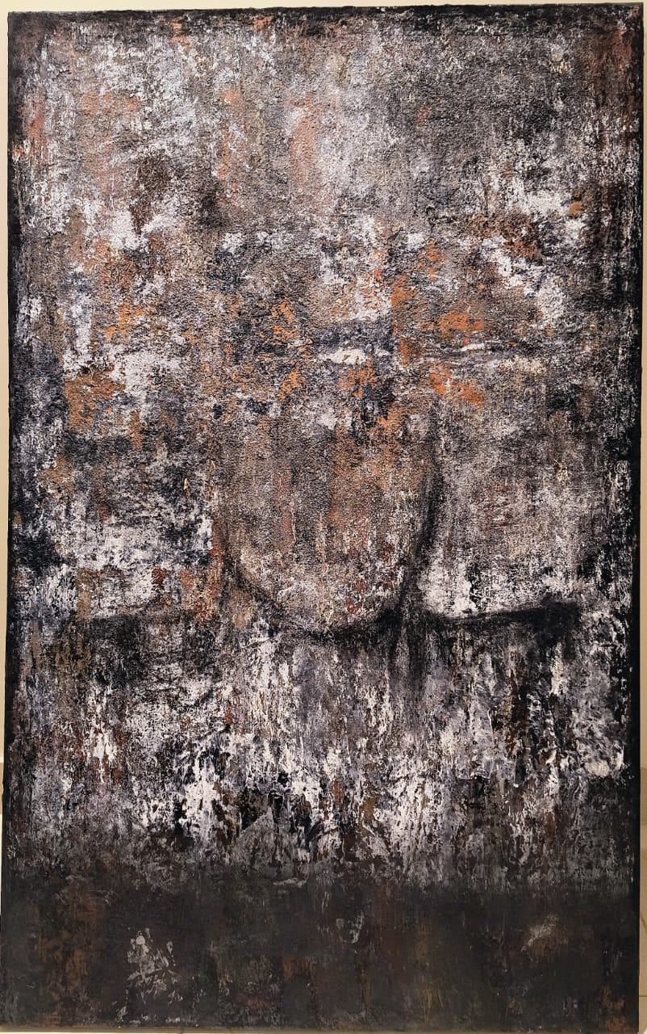 | "Black Snow", Textured Acrylic and black charcoal  This heavily textured abstract uses a dark, monochromatic palette of black, white, and rust, creating a distressed, eroded surface texture. The composition is anchored by a solid black band at the bottom, contrasting with the chaotic, fractured paint application above.  120x75cm, Acrylic on canvas
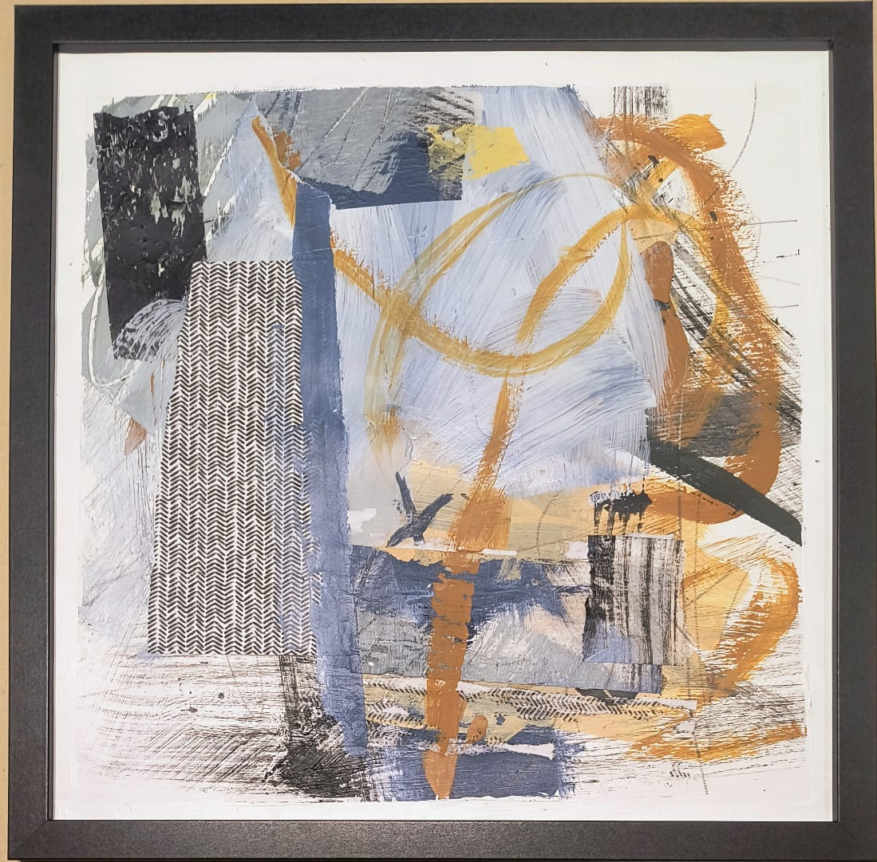 | "Rebellion 01", Acrylic Textured  This series of abstract collages deconstructs the theme of boundaries through chaotic layering and mixed media. Defined shapes (patterns, text) and fluid paint (blues, ochres) clash and overlap, illustrating the collapse of rigid borders between structure and freedom.  30x30cm, Framed, Acrylic on watercolor Fabriano 300gr paper
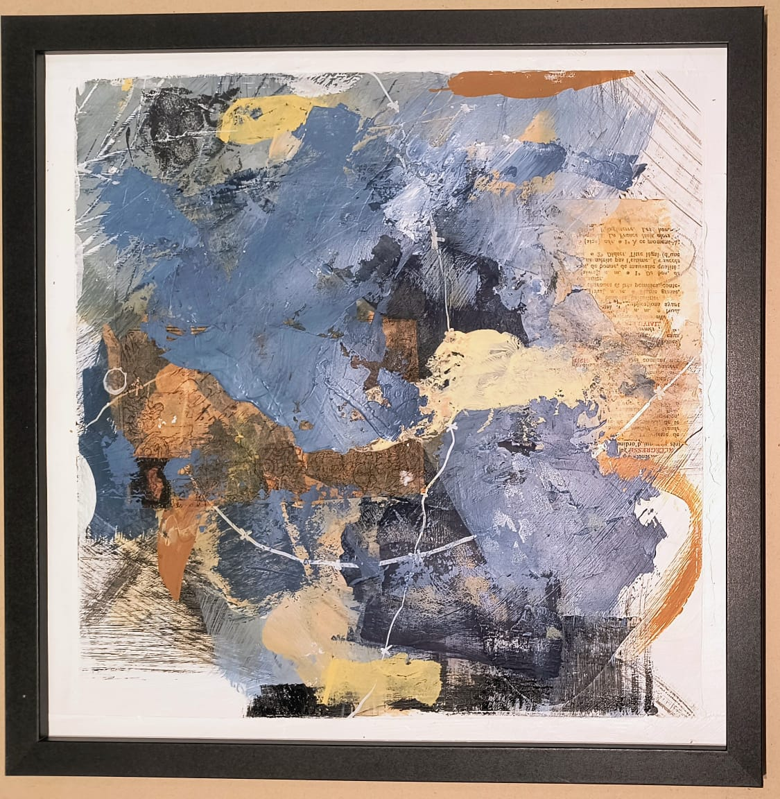 | "Rebellion 02",  Acrylic Textured  30x30cm, Framed, Acrylic on watercolor Fabriano 300gr paper
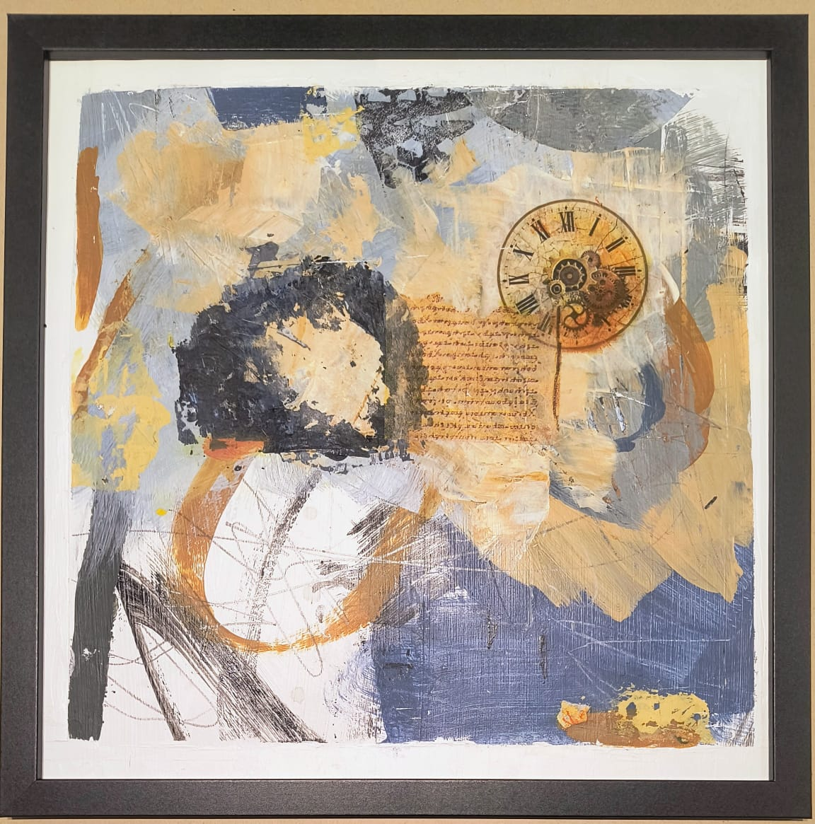 | "Rebellion 03", Acrylic Textured  30x30cm, Framed, Acrylic on watercolor Fabriano 300gr paper
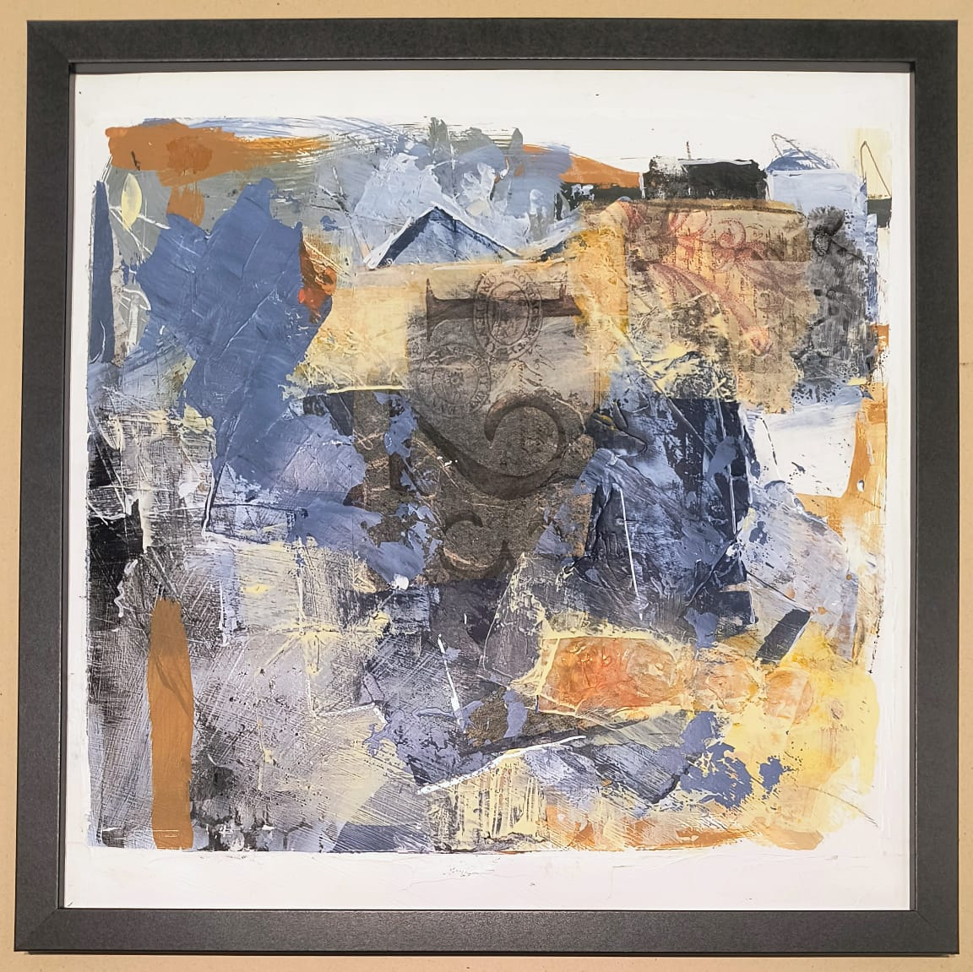 | "Rebellion 04",  Acrylic Textured  30x30cm, Framed, Acrylic on watercolor Fabriano 300gr paper
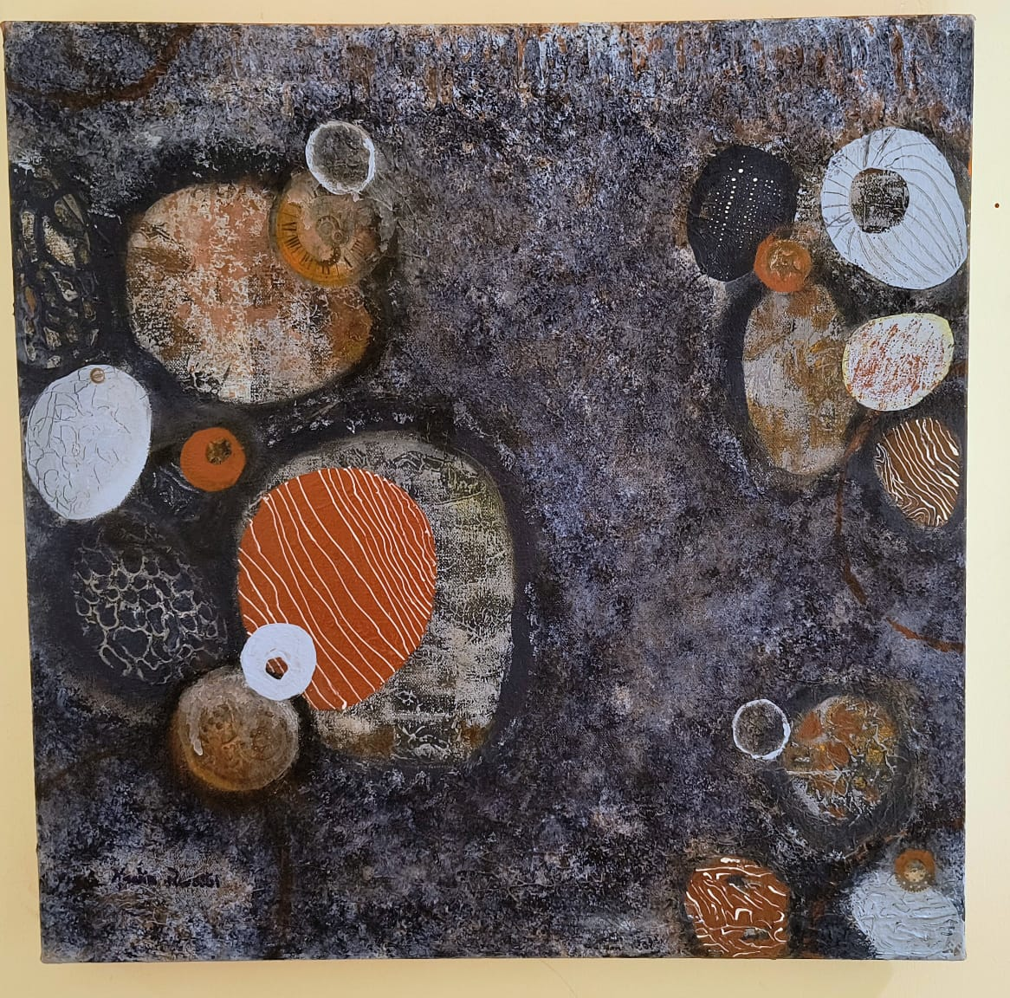 | "Les Galets" series is composed of Acrylic Textured  This abstract pieces. This central painting features a dark, textured background punctuated by an arrangement of irregular, cell-like ovals and circles. These pebbles (galets) reveal fractured interiors of light blue and oxidized earth tones.  50x50cm, Acrylic on canvas
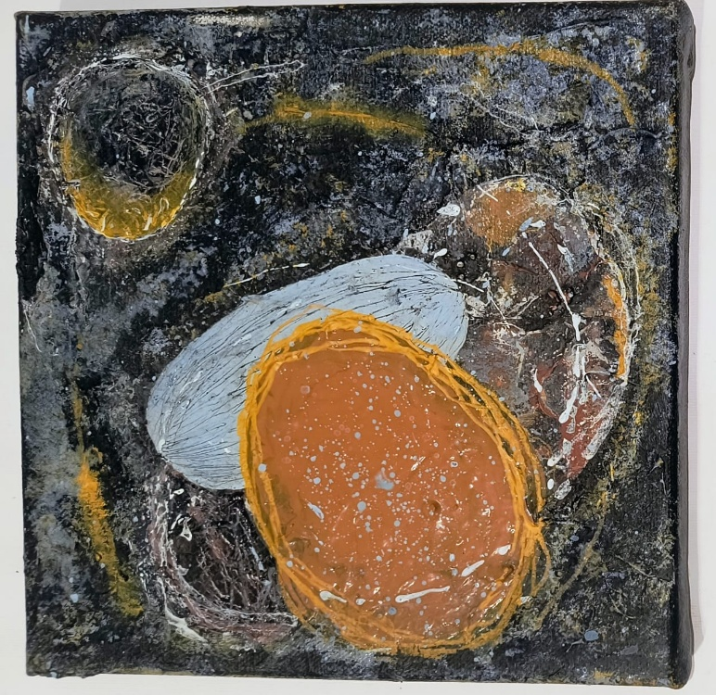 | "Little Galets 01", Acrylic Textured  20x20cm, Acrylic on canvas
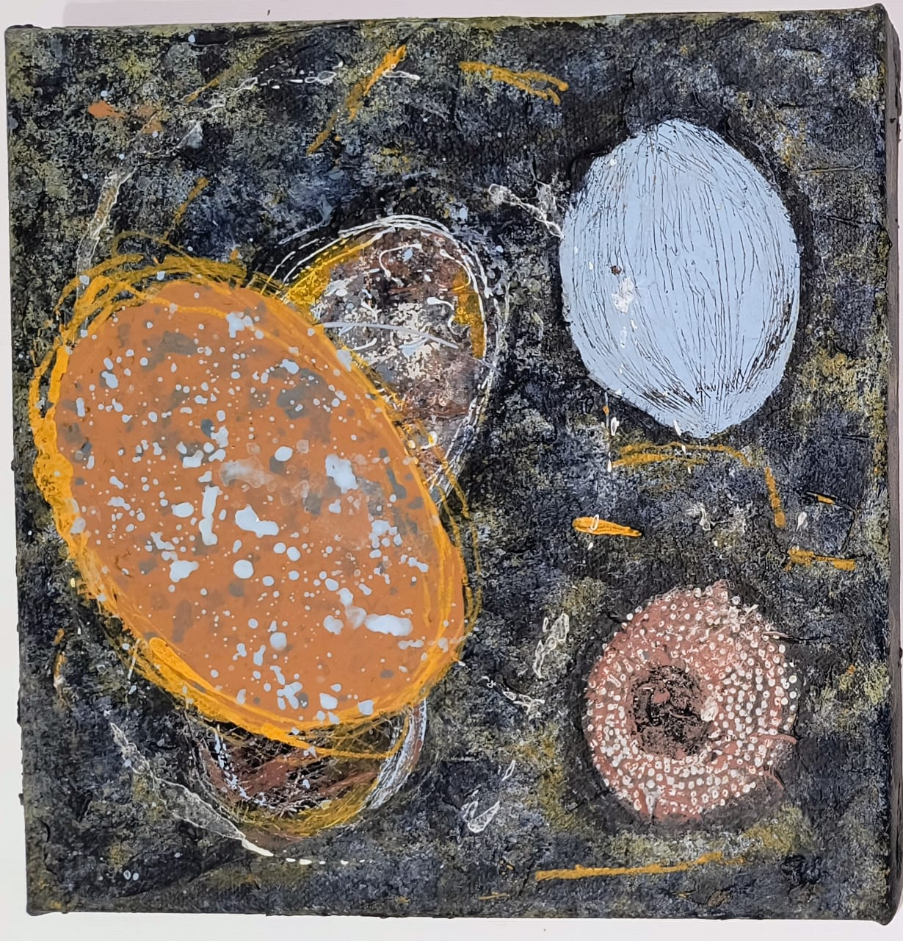 | "Little Galets 02", Acrylic Textured  20x20cm, Acrylic on canvas
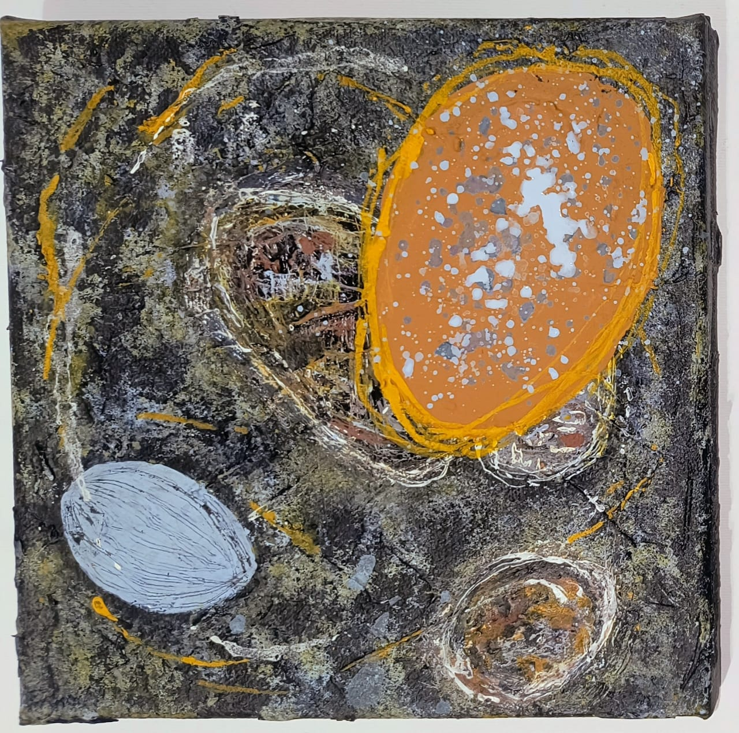 | "Little Galets 03", Acrylic Textured  20x20cm, Acrylic on canvas
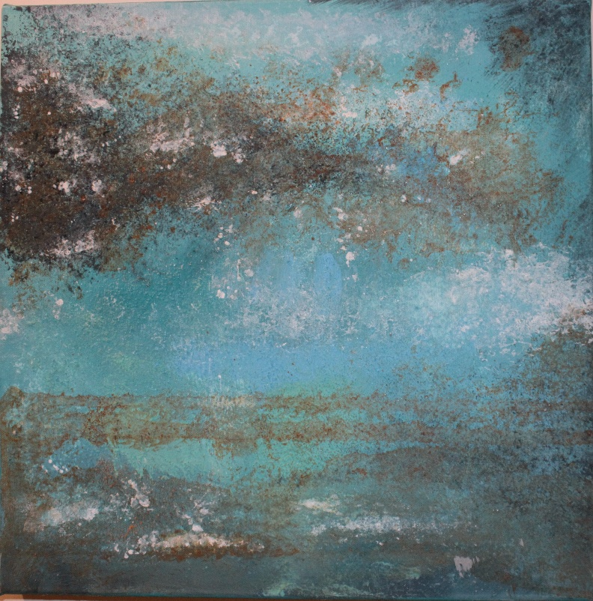 | "Blurred", Acrylic Textured  This painting uses textured layers of teal and turquoise to question definition. The dark horizontal bands act as visually porous boundaries, showing how distinctions between water, air, and the underlying surface are continually blurred and broken by shifting light and texture.  40x40cm, Acrylic on canvas
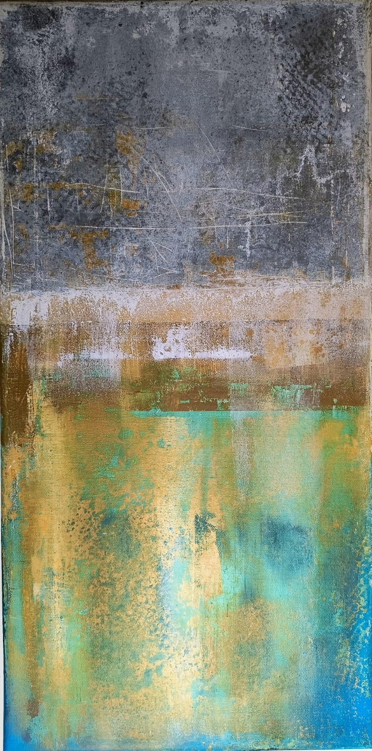 | "Silver age", Acrylic Textured  This abstract composition is structured horizontally, contrasting a textured, cool grey upper field with a vibrant lower section dominated by ochre and luminous turquoise. A central horizontal band, featuring broad strokes of umber and white, acts as a boundary line, separating the atmospheric texture above from the dynamic, fluid application of color below.  60x30cm, Acrylic on canvas
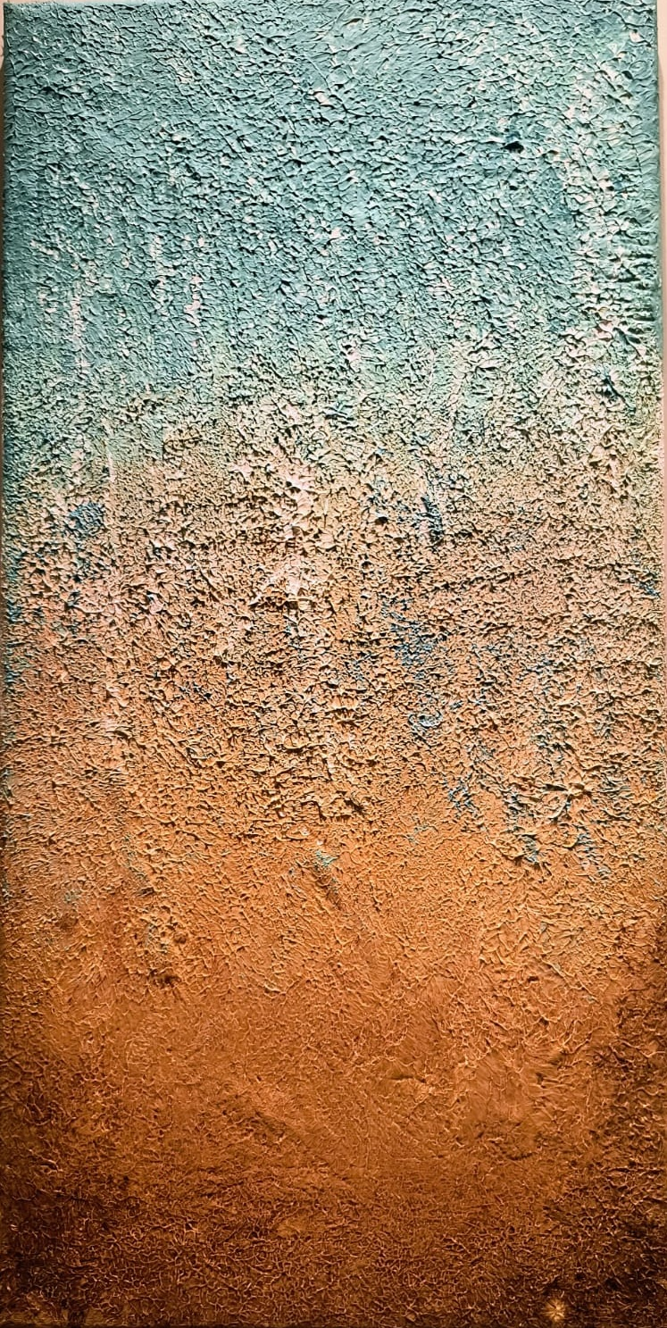 | "Sandy blue", Acrylic Textured  This abstract piece uses an extremely heavy impasto technique to create a rough tactile surface across the entire canvas. The composition is divided vertically by a dramatic color gradient, moving from a cool, mottled turquoise in the upper section to a rich, warm sienna and ochre below.  60x30cm, Acrylic on canvas

